 **PRESS RELEASE Prague, 28th November 2017**

# Christmas Office Design Market in BB Centrum

**On December 6th, the mall in the FILADELFIE building in the multifunctional** [**BB Centrum**](http://www.bbcentrum.cz/) **complex in Prague 4 will be filled with more than 30 Czech designers. The** [**Christmas Office Design Market**](https://www.keyevent.cz/officemarke) **sales exhibition will present the work of interesting Czech producers of fashions, jewellery, leather goods, home accessories, toys, graphics, and much, much more. A Christmas atmosphere will waft through the entire market, supported by stands with confections, a special Christmas menu and musical accompaniment by a pianist. The Office Design Market will be open in the FILADELFIE building mall on December 6th from 11 a.m until 6 p.m.**

BB Centrum, in cooperation with [KeyEvent](https://www.keyevent.cz/), is organising the Christmas Office Design Market in the shopping mall in the FILADELFIE building in Prague 4. New and established Czech designers, working with diverse materials, will be presenting their wares here. The stands will include, for example, [Alex Monhart](https://alexmonhart.com/) – a designer of urban backpacks popular in Berlin and Prague, [Kartoons](http://www.kartoons.cz/), a producer of cardboard furniture and accessories, the jeweller [Dana Bezděková](http://www.danabezdekova.cz/index.php) and the famed fashion designers Hana Zárubová, Monika Drápalová and others. The designer confectioner studio [DOUX Cake Boutique](http://www.doux.cz/), [Michelle's Bakery](http://www.michelles-bakery.cz/) and the maker of chocolate cakes [Od bobu](http://www.odbobu.com/) will also be preparing something for those visitors with a sweet tooth.

You can find more information and news at the [Office Market BB Centrum](https://www.facebook.com/OFFICEDESIGNMARKET/) Facebook page.

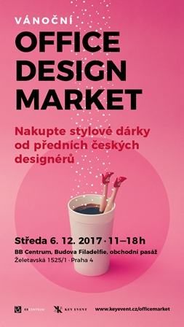

For more information and photographs in print quality please contact:

Kristýna Samková, Head of Marketing and PR

**PASSERINVEST GROUP, a.s.**

Tel.: (+420) 221 582 111

Mobil: (+420) 602 186 708

E-mail: [Kristyna.Samkova@Passerinvest.cz](mailto:Kristyna.Samkova@Passerinvest.cz)

[www.passerinvest.cz](http://www.passerinvest.cz/), [www.bbcentrum.cz](http://www.bbcentrum.cz)

Marcela Štefcová

**Crest Communications a.s.**

Tel.: (+420) 222 927 125

Mobil: (+420) 731 613 669

E-mail: [marcela.stefcova@crestcom.cz](mailto:marcela.stefcova@crestcom.cz)

**Information for editors**

**PASSERINVEST GROUP, a.s.,** founded in 1991 by Radim Passer, is a purely Czech development and investment company whose name is associated in particular with the **BB Centrum** multifunctional complex in Prague 4 - Michle. With this project, the most successful and extensive Czech project of its type, the company has built its excellent reputation both at home and at the international level. Contributing to this is not only the high quality of the projects completed to date, but also its high level of service, its sense of fair play, its positive relationship with the tenants and users of its buildings, and its sense of responsibility towards society and the environment. **PASSERINVEST GROUP**’s portfolioincludes other interesting development projects.